Design Updates
URL:
http://us15.campaign-archive2.com/?u=12a794b2402eb103cba5c25f4&id=84fea90f65
- Post my Flight Button - Button needs to be moved further left
Currently:
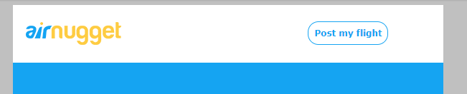
Updated:
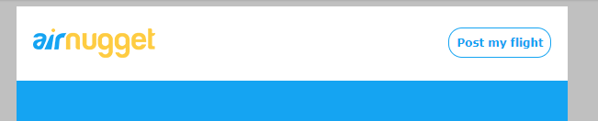
- All 3 icons are too small – size of icons not same as provided designs – please increase size also please make sure the icons are not blurry and have good resolution
Currently
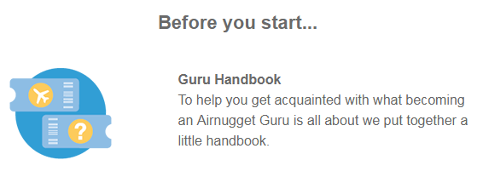
Update – Icon Should be sized and positioned same as below
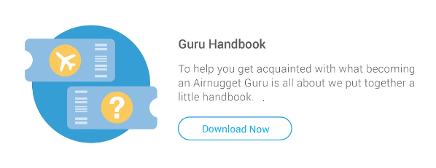

- Buttons are not aligned with text – all 3 buttons are not aligned with text
Current:
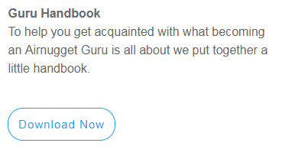

Update – the buttons need to be aligned and close to the text above
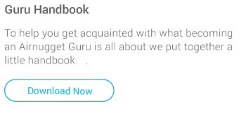
- Button Link URL – Please update as below
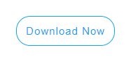
https://airnugget.com/Airnugget%20-%20Guru%20Handbook.pdf
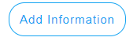
https://airnugget.com/guru_profile
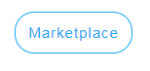
https://airnugget.com/marketplace


https://plus.google.com/116469662694192725459/about

- Update Airbnb wording
Currently:
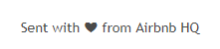
Update:
Sent with “heart” from Airnugget HQ

- Logo Link – Add link to Logo

https://airnugget.com/
- Copy update – spelling mistake
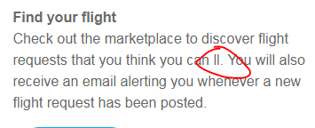
Should be fill

